RIDEspan ACTIVE RECREATION SYSTEMS
PROJECT PLANNING PACK · 2026
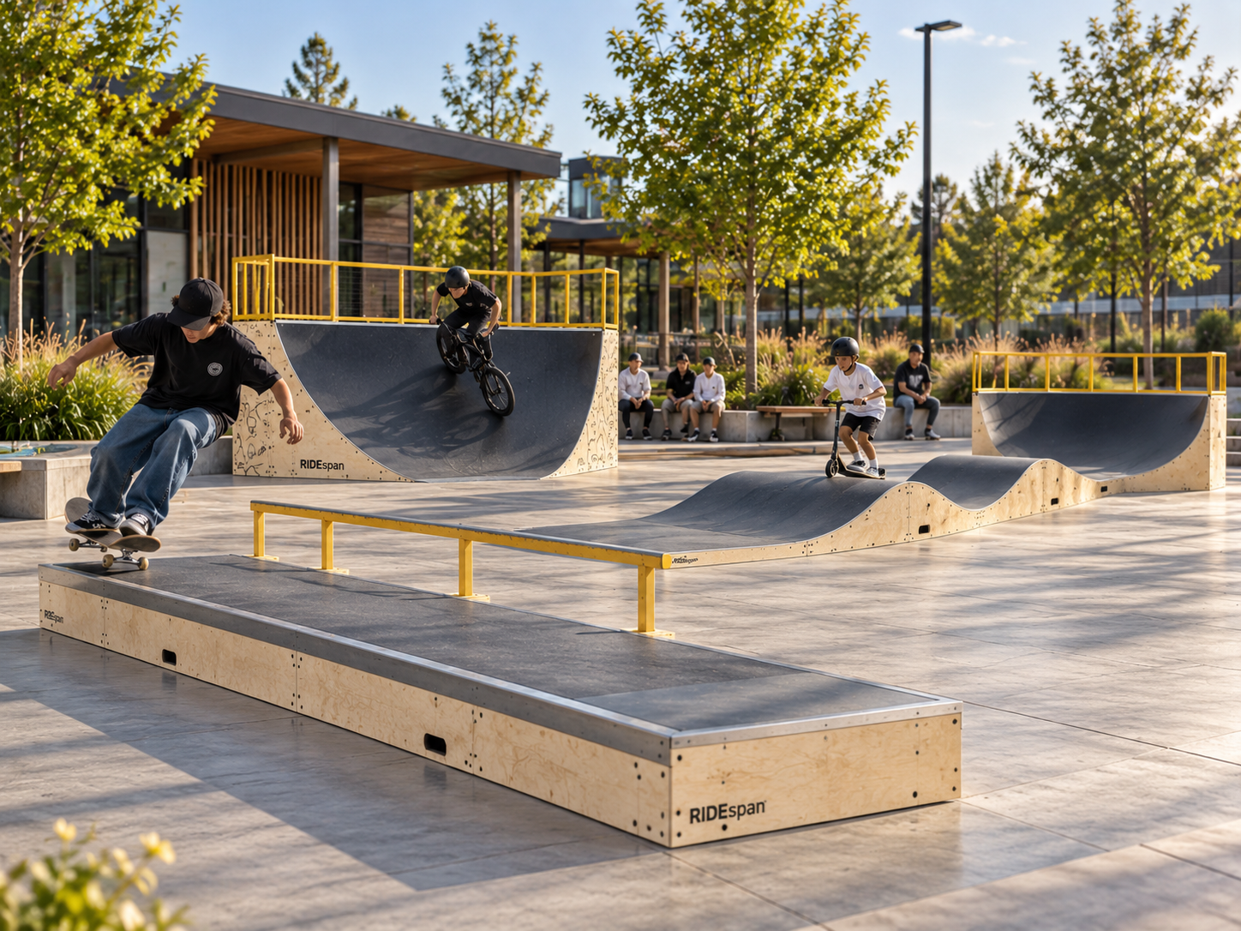

Plan the outcome before the equipment.
An editable project brief for RIDEspan PUMP, FLOW, STREET, SKILLS and PARK projects. Use it to structure the site, users, activity mix, evidence requirements, supply boundaries, logistics and handover.
PLANNING DOCUMENT - not a construction, engineering or product certification document.

HOW TO USE THIS PACK

Four decisions before product selection
Complete the early project sections first. The technical evidence and exact equipment schedule should follow the selected system - not lead it.
01 | Project type  School, council, resort, developer or complete destination.
02 | Primary activity  Mixed wheeled recreation, pump-track riding, street riding or bike skills.
03 | Site character  Compact, flexible community-scale or large destination site.
04 | Project goal  Progression, staged growth, dedicated activity or multi-activity destination.

RIDEspan pathway logic
PUMP | Complete continuous modular pump-track circuit.
FLOW | Compact configurable riding lines and staged recreation.
STREET | Skate / scooter / BMX street and transition systems.
SKILLS | BMX / MTB bike progression - exact manufactured range still under qualification.
PARK | Complete project wrapper when several activity systems share the site.

SECTION 01

Project profile
Record the basic commercial brief before discussing exact modules.
Project name | [Enter project name]
Client / organisation | [Enter client / organisation]
Project type | ☐ School ☐ Council ☐ Developer ☐ Resort / Destination ☐ Other
Site address / region | [Enter site location]
Delivery country / region | [Enter destination]
Primary contact | [Name / role / email / phone]
Current project stage | ☐ Early concept ☐ Budgeting ☐ Procurement ☐ Tender ☐ Delivery planning
Target programme | [Target decision / delivery / opening dates]
Budget status | ☐ Unknown ☐ Early allowance ☐ Approved budget ☐ Staged budget
Prepared by / date | [Name and date]

Project outcome
[In two or three sentences, describe what the project needs to achieve and why.]
Success measures | [Participation / community need / school use / guest experience / development outcome]
Known constraints | [Site, budget, timing, approvals, neighbour, access, climate or operational constraints]

SECTION 02

Site & context
The available footprint is only one part of the site brief.
Approx. available area | [Length x width / m² / site-plan reference]
Existing surface | ☐ Concrete ☐ Asphalt ☐ Grass / landscape ☐ Other ☐ Unknown
Ground / level condition | ☐ Level ☐ Sloping ☐ Mixed ☐ Survey required
Vehicle / service access | [Describe access and restrictions]
Pedestrian approaches | [Paths, gates, school access, parking, public transport]
Drainage / water | [Known drainage / flooding / runoff issues]
Power / lighting | [Existing power / lighting or future requirement]
Exposure | [UV / rain / frost / wind / coastal / seasonal issues]
Neighbour interfaces | [Homes, roads, classrooms, hospitality, sports fields, etc.]

Site documents available
☐ Site survey / dimensions | ☐ Site plan / masterplan
☐ Photos from all sides | ☐ Services information
☐ Drainage information | ☐ Geotechnical / civil information
☐ Landscape plan | ☐ Planning / consent information

SECTION 03

Users, activity & progression
Decide who the park is for and what they should be able to do there.
Primary users | ☐ Children ☐ Youth ☐ Adults ☐ Families ☐ Clubs / programmes
Expected skill range | ☐ Beginner ☐ Intermediate ☐ Advanced ☐ Mixed
Primary activities | ☐ Pump track ☐ Scooter ☐ Skateboard ☐ BMX ☐ MTB / bicycle ☐ Inline
Supervision model | ☐ School staff ☐ Passive public use ☐ Coach / programme ☐ Resort staff ☐ Other
Peak-use pattern | [Expected busy periods / group sizes / programme use]
Shared use | [Community access, school use, events, club use, tourism, etc.]

Progression priorities
☐ Low-consequence beginner start | ☐ Repeatable rhythm / pumping
☐ Street-style trick progression | ☐ Bike-specific technical progression
☐ Separate beginner and faster zones | ☐ Coaching / programme use
☐ Future progression stage | ☐ Event / competition potential

Known exclusions / restrictions
[Record any disciplines, ages, operating times or activities the project must not support.]

SECTION 04

RIDEspan system selection
Use the project outcome to choose the starting pathway. Several systems can later combine under PARK.
System | Use when... | Typical role | Status | Select
PUMP | A complete continuous riding circuit is the core brief. | Dedicated pump track | Established pathway | ☐
FLOW | The site is compact, configurable or likely to be staged. | Compact flow / progression | Development range | ☐
STREET | Street and transition riding is the priority. | Skate / scooter / BMX zone | Initial range selected | ☐
SKILLS | The brief is bike-specific technical progression. | BMX / MTB progression | In development | ☐
PARK | Two or more systems / amenities need to work as one destination. | Complete park wrapper | Project-led pathway | ☐

Initial selected pathway
Primary system | [PUMP / FLOW / STREET / SKILLS / PARK]
Secondary system(s) | [If relevant]
Why this pathway fits | [Short rationale]
Alternative considered | [Other system and reason not selected]

SECTION 05

PARK planning layers
Use these even for smaller projects. They prevent good equipment from being placed into a poor site layout.
01 | Activity core | Choose systems around actual rider groups.
02 | Rider circulation | Entry, exit, waiting, crossings and transitions.
03 | Progression | Separate introductory, intermediate and higher challenge.
04 | Spectators / supervision | Keep stationary users outside rider flow.
05 | Public realm | Shade, seating, hydration, bike parking, bins and paths.
06 | Lighting / services | Power, drainage, maintenance access and future amenities.
07 | Expansion zone | Protect future modules and connection points.
08 | Handover / lifecycle | Inspection, maintenance, spares and responsibilities.

Indicative reference layout
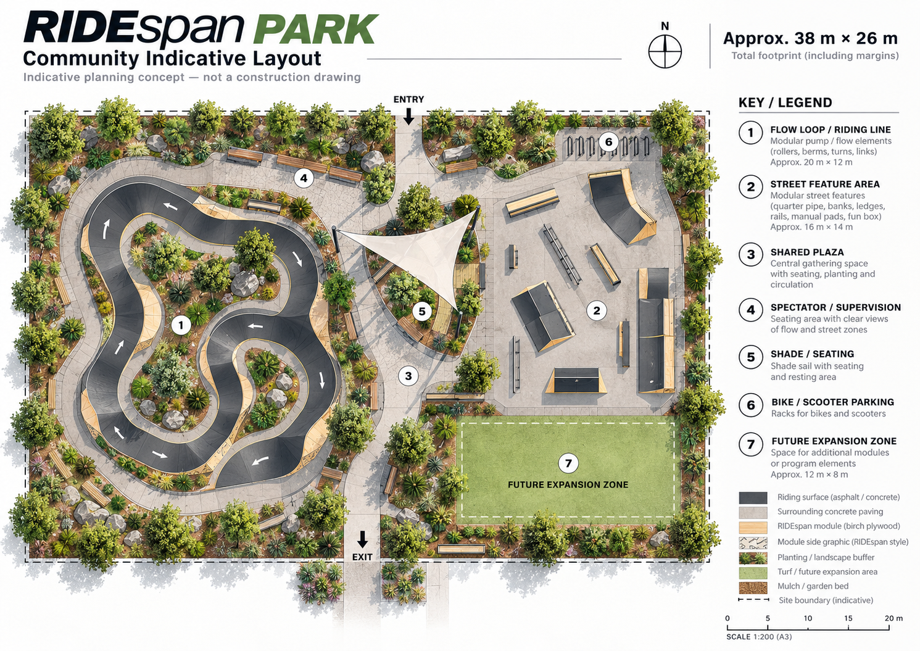
Indicative planning concept only - not a construction, engineering or final equipment drawing. Approximate concept dimensions shown in the image are not standard product sizes.

SECTION 06

Technical evidence schedule
Do not release a public or project claim until it is tied to the exact offered system.
Evidence area | Status | Required for this project? | Notes / document reference
System definition | Verified / public | ☐ Yes ☐ No | [Document / note]
Exact model / product family | Mixed status | ☐ Yes ☐ No | [Document / note]
Frame / structure | Await exact evidence | ☐ Yes ☐ No | [Document / note]
Riding surface | Await exact evidence | ☐ Yes ☐ No | [Document / note]
Outdoor durability | Await exact evidence | ☐ Yes ☐ No | [Document / note]
Corrosion / coastal suitability | Await exact evidence | ☐ Yes ☐ No | [Document / note]
Anchoring / foundations | Project specific | ☐ Yes ☐ No | [Document / note]
Structural / impact information | Project specific | ☐ Yes ☐ No | [Document / note]
Applicable standards | Evidence controlled | ☐ Yes ☐ No | [Document / note]
Rider / discipline suitability | Model specific | ☐ Yes ☐ No | [Document / note]
Maintenance / spares | Final release required | ☐ Yes ☐ No | [Document / note]
Warranty | Final commercial release | ☐ Yes ☐ No | [Document / note]
Packing / freight data | Project specific | ☐ Yes ☐ No | [Document / note]
Rule: never infer EN 14974 compliance, structural capacity, coastal durability or universal discipline suitability from product appearance or generic supplier marketing.

SECTION 07

Supply & responsibility matrix
Confirm who owns each interface before the equipment schedule is frozen.
Scope item | RIDEspan / supply | Client | Local contractor / consultant | Notes
Site survey / dimensions | ☐ | ☐ | ☐ | [Note]
Geotechnical / ground assessment | ☐ | ☐ | ☐ | [Note]
Civil design / drainage | ☐ | ☐ | ☐ | [Note]
Concrete / asphalt base | ☐ | ☐ | ☐ | [Note]
Foundations / anchors | ☐ | ☐ | ☐ | [Note]
RIDEspan equipment supply | ☐ | ☐ | ☐ | [Note]
Freight to agreed point | ☐ | ☐ | ☐ | [Note]
Unloading / storage | ☐ | ☐ | ☐ | [Note]
Installation / assembly | ☐ | ☐ | ☐ | [Note]
Electrical / lighting | ☐ | ☐ | ☐ | [Note]
Landscape / public realm | ☐ | ☐ | ☐ | [Note]
Local approvals / consent | ☐ | ☐ | ☐ | [Note]
Inspection / commissioning | ☐ | ☐ | ☐ | [Note]
Operating signage | ☐ | ☐ | ☐ | [Note]
Maintenance / inspections | ☐ | ☐ | ☐ | [Note]
Warranty / spares | ☐ | ☐ | ☐ | [Note]

SECTION 08

Logistics & delivery planning
The project is not ready for freight until the final equipment and receiving constraints are understood.
Delivery destination | [Port / depot / project site / agreed delivery point]
Access restrictions | [Truck, container, crane, school hours, resort operations, etc.]
Unloading method | [Forklift / crane / manual / contractor plan]
Temporary storage | [Secure, dry, accessible storage available?]
Packing requirement | [Crates / pallets / protection / identification]
Container / shipment plan | [To be completed against final equipment schedule]
Import / customs responsibility | [Client / broker / Apollo / other]
Installation sequence | [Site readiness and expected installation sequence]

Pre-shipment checks
☐ Final product schedule approved | ☐ Technical evidence accepted
☐ Drawings / manuals released | ☐ Packing list issued
☐ Weights / package dimensions confirmed | ☐ Delivery address confirmed
☐ Unloading equipment booked | ☐ Storage area ready
☐ Local works ready | ☐ Damage / receipt process agreed

SECTION 09

Handover, inspection & lifecycle
The equipment handover should make ownership clear, not simply confirm that boxes arrived.
☐ Final equipment / module schedule | ☐ As-supplied drawings
☐ Installation / assembly manual | ☐ Inspection requirements
☐ Routine maintenance schedule | ☐ Replacement surface / panel details
☐ Hardware / spare-parts list | ☐ Warranty schedule and exclusions
☐ Cleaning / weathering guidance | ☐ Fault / closure procedure
☐ Supplier / project contacts | ☐ Training or operating notes where applicable

Owner responsibilities
Inspection owner | [Person / role / contractor]
Inspection frequency | [Daily / weekly / monthly / manufacturer requirement]
Maintenance owner | [Person / organisation]
Fault reporting | [Process / contact]
Temporary closure authority | [Who may close a feature / zone?]
Spare-parts storage | [Location / responsible person]
Review date | [First lifecycle review / post-opening review]

SECTION 10

Project submission checklist
A concise first package is enough to start productive project review.
☐ Completed Project Profile | ☐ Site location and available area
☐ Site plan / survey if available | ☐ Current site photos
☐ Primary users and age groups | ☐ Preferred activity / RIDEspan pathway
☐ Expected skill range | ☐ Existing surface / site condition
☐ Lighting, shade, seating and amenity requirements | ☐ Future expansion or staged budget
☐ Target programme / delivery region | ☐ Known approvals / consultant requirements

Files / links supplied
__________________________________________________________________________________________
__________________________________________________________________________________________
__________________________________________________________________________________________
__________________________________________________________________________________________
__________________________________________________________________________________________

Additional notes
__________________________________________________________________________________________
__________________________________________________________________________________________
__________________________________________________________________________________________
__________________________________________________________________________________________
__________________________________________________________________________________________
__________________________________________________________________________________________
__________________________________________________________________________________________
__________________________________________________________________________________________

RIDESPAN ACTIVE RECREATION SYSTEMS

Plan the outcome. Select the pathway. Release the evidence.
This planning pack is designed to help move a project from early idea to a controlled brief without turning unverified development information into specification claims.
Primary RIDEspan pathway | [PUMP / FLOW / STREET / SKILLS / PARK]
Project reference | [Project name / reference]
Next action | ☐ Site review ☐ Concept layout ☐ Technical evidence ☐ Budget / quote ☐ Project meeting
Target next date | [Enter date]

Useful project resources
System Selector | apollonzglobal.com/ridespan/selector
System Comparison | apollonzglobal.com/ridespan/compare
RIDEspan PARK | apollonzglobal.com/ridespan/park
Technical Evidence Centre | apollonzglobal.com/ridespan/technical-evidence
Specification & Planning Centre | apollonzglobal.com/ridespan/specification-centre

Supply-only project pathway. Local survey, civil works, engineering, installation, accessibility, safety and statutory responsibilities must be confirmed in the project scope.

